

MINI PROJECT ON

“Old Book Shearing”

SUBMITTED IN FULFILLMENT OF REQUIREMENTS

BY

Kuldeep Lodhi 15102A0025

Kalpesh Brid 12

Gopal Bhoi 14102A0024

Mayur Wadile 15102A0023

**Under the guidance of**

**Prof. Prita Patil**



Department of Computer Engineering

2017 – 2018

**Table of content**

|  |  |  |
| --- | --- | --- |
| SR NO. | CONTENT | PG NO. |
| 1. | Acknowledgement | 03 |
| 2. | Abstract | 04 |
| 3. | Objectives | 05 |
| 4. | Plan of Work | 07 |
| 5. | Technologies used | 08 |
| 6. | Requirement Gathering | 09 |
| 7. | Designs of project | 10 |
| 8. | Feasibility Study | 13 |
| 9. | Future Enhancement | 14 |
| 10. | Screenshots | 15 |
| 11. | Bibliography | 18 |

**Acknowledgement**

We feel privileged to express our deepest sense of gratitude and sincere thanks to our guide **PROF. Ketan kanare** for his excellent guidance throughout the project work. His prompt and kind help directed us to the completion of dissertation work.

We would also thank the lab assistance of computer department for providing us with the requisite facilities to complete the project work.

Finally, we would like to acknowledge all our friends those who directly or indirectly helped us in the completion of our project.

**ABSTRACT**

Online Election System would have Candidate registration, document verification, User ID and pass for candidate and Voters. Admin Login which will be handled by Election Commission .Candidate Login which will be handled By Candidate, Voters will get Unique ID and Password, Using which they can vote for a Candidate only once per Election. The project is beneficial for Election Commission, Voters as the can get to know the candidate background and choose wisely, and even for Candidate. The software system allows the Candidate to login in to their profiles and upload all their details including their previous milestone onto the system. The admin can check each Candidate details and verify the documents, only after verifying Candidate’s ID and Password will be generated, and can remove faulty accounts. The software system allows Voters to view a list of Candidates in their area. The admin has overall rights over the system and can moderate and delete any details not pertaining to Election Rules.

**Objectives**

**1. Democracy: The system should be "democratic" in the sense that:**  
 it will permit only eligible voters to vote  and   
 it will ensure that each eligible voter can vote only once.

**2. Privacy: The system should ensure that:**  
 none of the actors involved in the voting process can link any ballot  to the voter who cast it, and   
 that no voter can prove that he or she voted in a particular way.

**3. Integrity: The necessary mechanism should be employed in order to guarantee that:**  
 noone can duplicate his or someone else's vote and    
 noone can change someone else's vote.

**4.Accuracy:**  
The system functionality should ensure that noone can falsify or modify the result of the voting by eliminating a valid vote or counting an invalid vote in the final tally.

**5.Verifiability:**  
The system should allow and support anyone to independently verify that all votes have been counted correctly.

**6.Convenience:**  
The system should allow and assist voters to cast their votes quickly, in one session, and with minimal equipment or specialskills.

**7.Flexibility:**  
The system should allow a variety of ballot formats and it should be customized to the specific characteristics of the voting processes.  
  
**8.Mobility:**  
The system should not pose any restrictions on the location from which a voter can cast a vote.  
  
**9.Efficiency:**  
The election can be held in a timely manner

**Plan of Work**

As to reached to the goal of our project we made some plan to be follow to get our project successfully implemented for this definitely we use one of the SDLC model called **Waterfall model.**

Waterfall model contains Requirement gathering, System designing, Implementation, System testing, System Deployment, System maintenance. So as per this we made plans, schedules etc.

Plan of work are as follows:

* Captured all the requirements, understands the requirements and do the feasibility test to ensure that the requirements are testable or not.
* As per the requirements create the design
* Captured the hardware/software requirements and documented the design.
* As per the design created the programs/code and integrated the codes for the next phase.
* Perform all the testing activities (Functional and Non-Functional) to make sure that the system meets the requirements.
* Deploy the application in the respective environments

**Technologies used**

This project will be a website to be developed in HTML, CSS, PHP and SQL server as backend.

**HTML**

 HTML is a markup language for describing web documents.

 HTML Stands for Hyper Text Markup Language.

 A markup language is a set of markup tags.

**CSS**

 CSS is Style sheet Language that describes the presentation of an HTML (or XML) document.

 CSS describes how elements must be rendered on screen, on paper, or in other media.

**PHP**

 PHP is a server scripting language, and a powerful tool for making dynamic and interactive Web pages.

 PHP is a widely-used, free, and efficient alternative to competitors such as Microsoft's ASP.

**JavaScript**

 JavaScript is the programming language of HTML and Web. Programming makes computers do what you want them to do.

 JavaScript is easy to learn.

**SQL**

 SQL is a standard language for accessing database.

 SQL lets you access and manipulate database.

 SQL is an ANSI (American National Standard Institute) standard.

**REQUIREMENT GATHERING**

**HARDWARE AND SOFTWARE REQUIREMENTS**

**HARDWARE REQUIREMENTS:**

* Processor – Dual Core
* Hard Disk – 50 GB
* Memory – 1GB RAM

**SOFTWARE REQUIREMENTS:**

* Windows Xp, Windows 7(ultimate, enterprise)
* Sql 2008
* Visual studio 2010

**Project Requirements:**

|  |  |
| --- | --- |
| **Functional Requirements** | **Non**- **Functional** **Requirements** |
| * Login | * Performance |
| * Sell book(upload book detail) | * Security |
| * Search book | * Reliability |
| ► Buy book | * Availability |
|  | * Safety |
|  | * Reusability |
|  | * Maintainability |

**Designs of project**

**Main System Use Case:**

Seller

Upload books

Search books

Payment

Register

Buyer

Administrator

Login

<<include>>

<personal Details

**Main System Class Diagram:**



**Main System Sequence Diagram:**





**Main System Activity Diagram:**



**State Diagram**

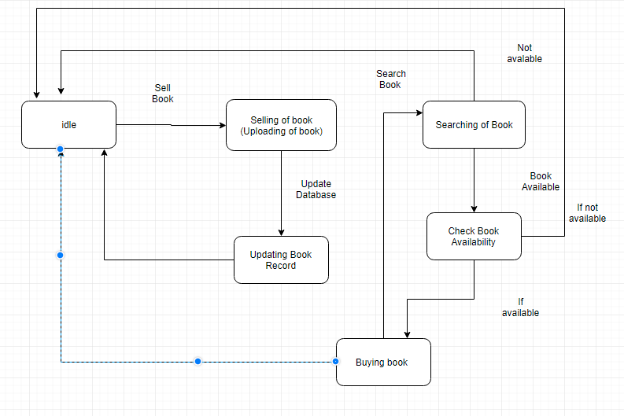

**Feasibility Study**

**TECHNICAL FEASIBILITY:**

Time & Legal Feasibility: In this type of feasibility study, we examine whether our proposed project can be completed in the specified time frame or not and it does not break any laws. So it is legally feasible too. Technical feasibility Our information system uses “HTML, CSS and PHP” on windows platform as a frontend and SQL as backend to store the database related shop billing system.

**BEHAVIOUR FEASIBILITY :**

As the project is very easy to implement with ease and convenience, behavioral analysis methods in a measure of how well a proposed system solves a problem and take advantages of opportunities identified during scope definition and how it satisfies the requirement analysis phase of system development.

**FINANCIAL AND ECONOMICAL FEASIBILITY:**

The cost of the hardware and software is feasible, as it requires investments at the start of the system. but a normal computer user will definitely poses the following configuration which is the requirement of the system we developed.

There is no need of any extra software or anything as we developed it on open source softwares.

**Screenshots**

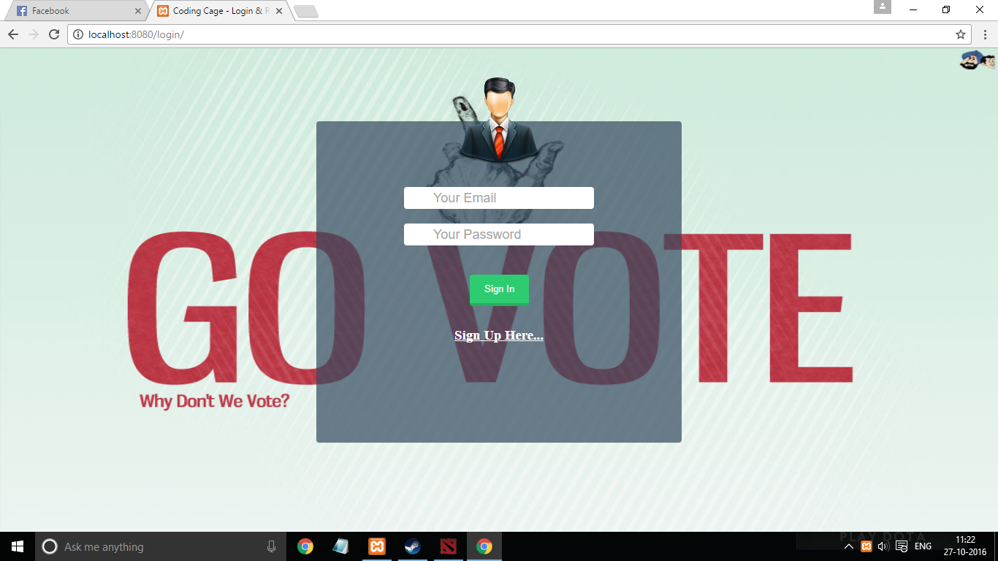

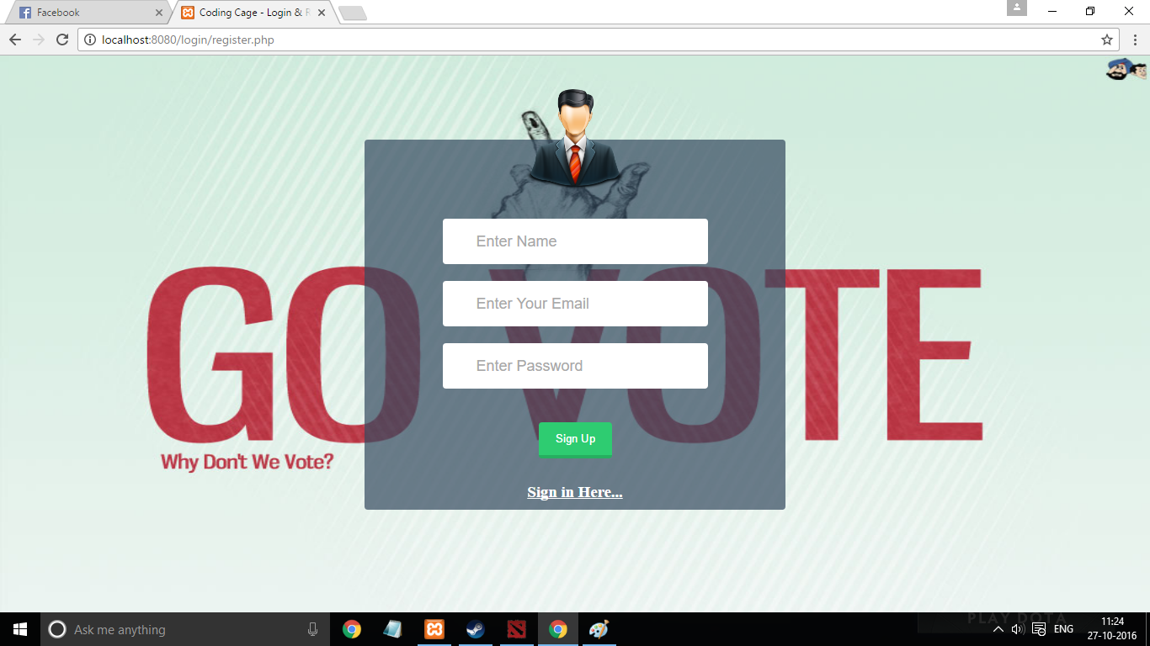

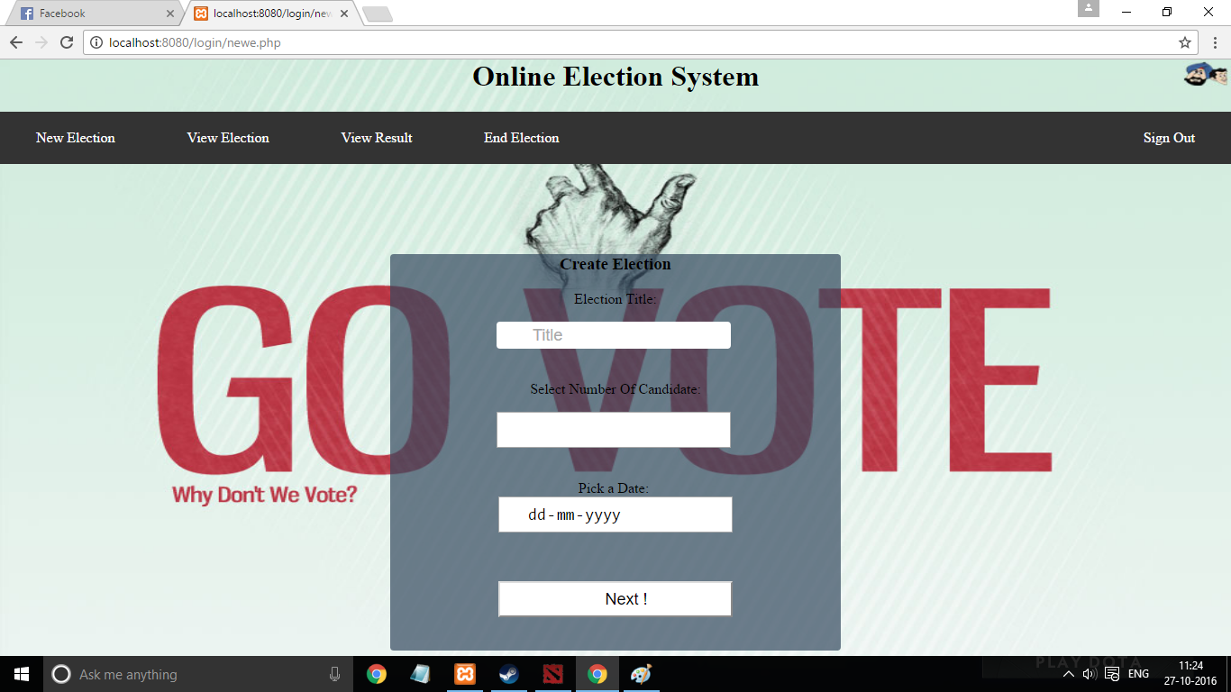

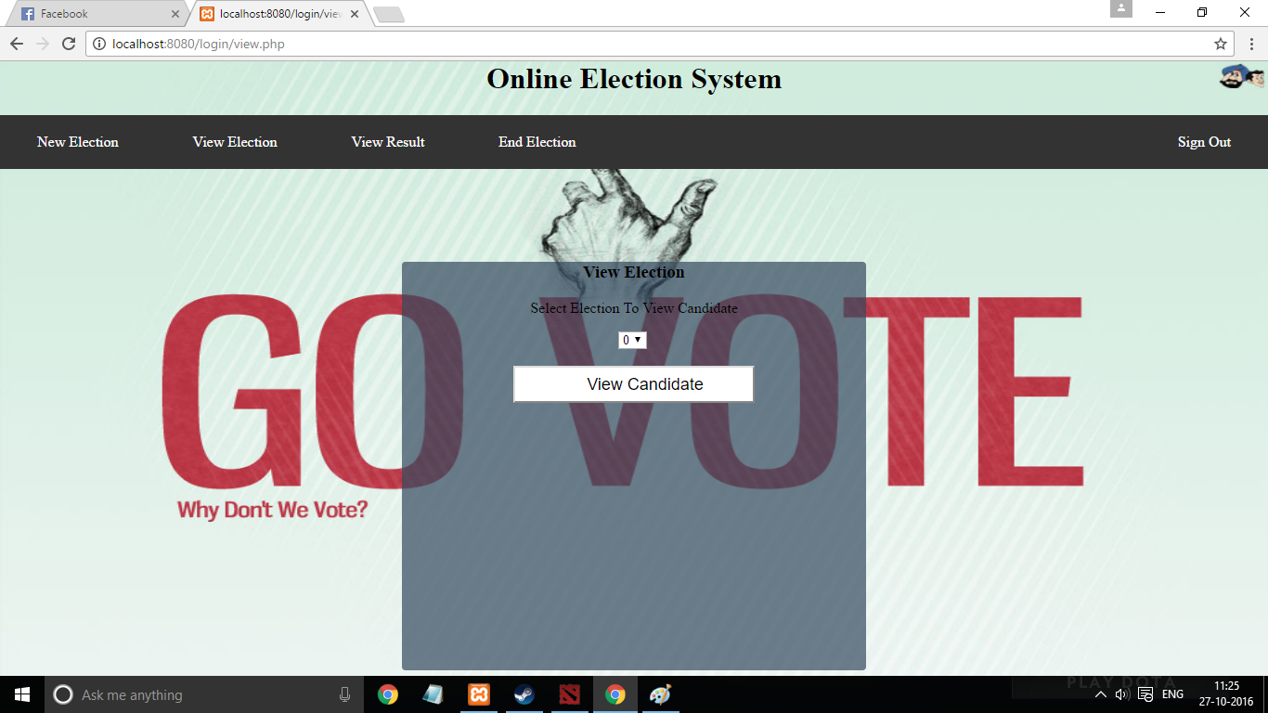

**Bibliography**

** Referred from websites**

* + http://www.w3schools.com
  + http://www.youtube.com
  + <http://www.google.com>
  + <http://www.olx.com>
  + http://www.quicker.com